AMAZON #1 BEST SELLING AUTHOR, STEVEN D. NIELSEN’S 5 BOOK SERIES, “TWO RUNS OF STONE”
BOOKS ONE THROUGH THREE:

‘A BECKONING CALL”
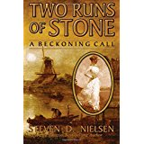

“WINDSHIPS AMERICA”
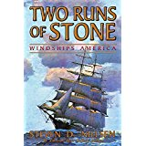

“HEART’S DESIRE”
