AMAZON #1 BEST SELLING AUTHOR, STEVEN D. NIELSEN’S 5 BOOK SERIES, “TWO RUNS OF STONE”
BOOKS FOUR AND FIVE:

“WAGONS WEST”
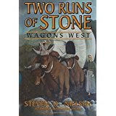

“FULL CIRCLE”
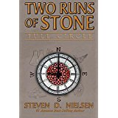

In ‘Full Circle”, A pioneer map and genealogy chart are included at the beginning of each section and a quick review of both will be invaluable for time and place orientation, not to mention the cast of characters in this exciting and thoroughly entertaining novel.

