CONGRATULATIONS
Steven D. Nielsen, #1 Amazon Best Selling Author in Mormonism!

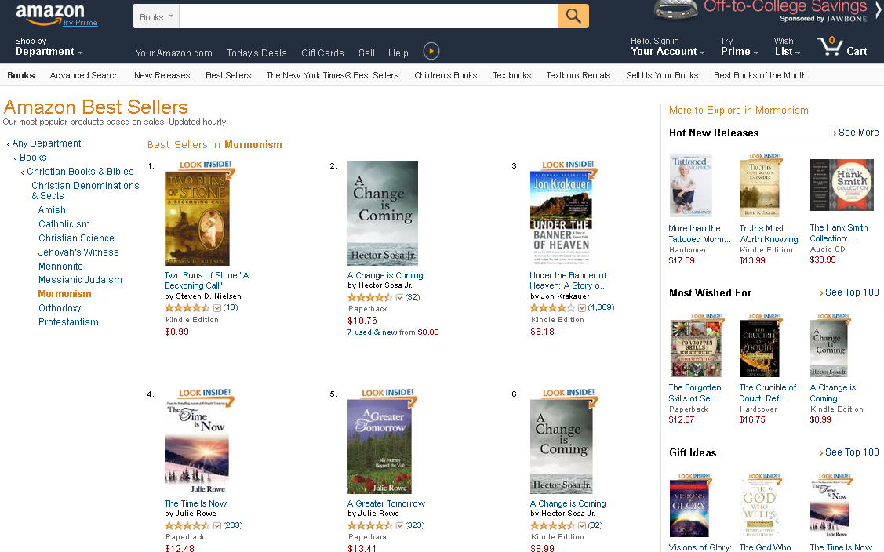

Steven D. Nielsen, #1 Best Selling Author of “A Beckoning Call”,
Two Runs of Stone, Book One in a Series of 5
