CONGRATULATIONS
Steven D. Nielsen, #1 Amazon Best Selling Author in
Church of Jesus Christ of Latter Day Saints!
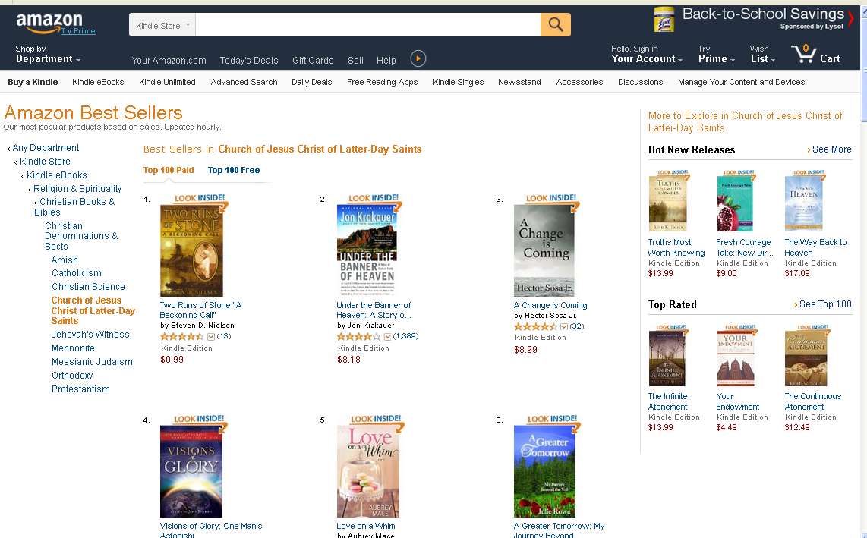

Steven D. Nielsen, #1 Best Selling Author of “A Beckoning Call”,
Two Runs of Stone, Book One in a Series of 5
